|  |  |
| --- | --- |
|  |  |

**Reuse of Ablution Water for Landscaping in Hayatabad Peshawar - A Step Towards Climate Change Adaptation**

Muhammad Umer Farooq Shah 1, Fayaz Ahmad Khan1, Afed Ullah Khan2, Saqib Mahmood2

1National institute of urban infrastructure planning, University of Engineering and Technology Peshawar, 2500, Pakistan

2Department of Civil Engineering, Campus III-Bannu, University of Engineering and Technology Peshawar, Bannu 28100, Pakistan

\***Correspondence**: [afedullah@uetpeshawar.edu.pk](mailto:afedullah@uetpeshawar.edu.pk)

**Citation**| Shah. M. U. F, Khan. F. A, Khan. A. U, Mahmood. S, “Reuse of Ablution Water for Landscaping in Hayatabad Peshawar - A Step Towards Climate Change Adaptation”, IJIST, Vol. 07 Issue. 03 pp 1466-1474, July 2025

**Received|** June 13, 2025 **Revised|** July 05, 2025 **Accepted|** July 10, 2025 **Published|** July 16, 2025.

R

apid urbanization and climate change have intensified water scarcity challenges in Pakistan, particularly in cities like Peshawar. This study assesses the feasibility of reusing mosque (masjid) ablution water to irrigate nearby green belts in Hayatabad, Peshawar, as a cost-effective and sustainable alternative to conventional tubewell irrigation. Spatial analysis showed that most green belts are located within a 450-meter radius of mosques, enabling the use of low-energy pumping systems. Economic analysis indicated that reusing ablution water could reduce daily transport and pumping costs by more than thirteenfold, significantly decreasing fuel consumption and greenhouse gas emissions. Water quality tests found that ablution water had BOD levels of 4.6–6 mg/L and COD of 10–12 mg/L, remaining within acceptable limits for non-potable irrigation use. Overall, the results demonstrate that the reuse of ablution water is technically feasible, environmentally beneficial, and aligns with Sustainable Development Goals (SDG 6 and SDG 13). This approach offers a scalable model to improve urban water resilience and reduce pressure on groundwater resources in water-stressed regions.

**Keywords:** Ablution Water Reuse, COD, BOD, Groundwater Conservation, Energy Efficiency, SDGs

|  |  |  |  |  |
| --- | --- | --- | --- | --- |
|  |  |  |  |  |
|  |  |  |  |  |
|  | Crossref - Wikipedia | ResearchGate - find and share research – Telegraph |  |  |

**Introduction:**

Water scarcity is among the most critical challenges facing the world today, particularly in arid and semi-arid regions like Pakistan. The country has witnessed a substantial reduction in per capita water availability, from 5,260 cubic meters in 1951 to less than 1,000 cubic meters in recent years, placing it in the category of “water-scarce” nations [1], [2]. Climate change has further intensified this dilemma through altering precipitation patterns, increasing drought frequency, and shrinking glacier reserves, posing severe threats to water security, agriculture, and urban sustainability [3].

Urban areas like Peshawar are witnessing rapid population growth and significant land use changes, leading to higher water consumption and placing increased strain on the city's aging water infrastructure [4], [5]. In addition to domestic use, a significant portion of urban water is used for maintaining green belts and landscapes. Landscaping, while essential for urban aesthetics, microclimate regulation, and ecosystem services, becomes a substantial burden on municipal water supply, especially during dry seasons [6]. With the growing severity of climate change impacts, it has become crucial to implement adaptive strategies that ensure the long-term sustainability of water resources. One potential solution is the reuse of greywater, which is defined as wastewater generated from non-toilet sources such as showers, sinks, and ablution (Wudu) facilities [7], [8]. Greywater reuse has been successfully adopted in various parts of the world for landscape irrigation, toilet flushing, and industrial processes, offering considerable potential to reduce freshwater demand and improve resilience to water shortages [9], [10].

Hayatabad, a planned township in the city of Peshawar, is home to dozens of mosques as well as green belts, gardens, and public parks. The potential to harness ablution water from mosques for the irrigation of local landscapes remains largely untapped in this area [11], [12]. By integrating greywater reuse within the existing urban structure, municipalities can reduce stress on freshwater resources, slash utility costs, and encourage environmentally conscious practices in line with both religious and sustainable development principles [13].

This study explores the feasibility of reusing ablution water from mosques for landscaping in Hayatabad, Peshawar, as a practical and culturally appropriate climate change adaptation strategy. The research aims to estimate the volume of ablution water generated across selected mosques and assess its physicochemical and microbiological characteristics to evaluate its suitability for non-potable reuse in landscape irrigation. It also examines the water demand for maintaining green spaces in Hayatabad and matches it with the available greywater supply to assess potential coverage. In addition to its environmental benefits, reusing ablution water provides substantial economic advantages. It decreases dependence on expensive freshwater supplies, reduces the need for extensive transportation or pumping systems by utilizing water close to its source and point of use, and eases the burden on rapidly depleting groundwater reserves. The findings emphasize how low-cost, locally sourced solutions can enhance water resilience, reduce environmental impact.

**Study Area, Data Collection, and Methods:**

**Study Area:**

Hayatabad is a well-planned residential township located in the southwestern part of Peshawar, the capital city of Khyber Pakhtunkhwa (KPK), Pakistan, as shown in Figure 1, which shows the township’s boundary, main phases (Phase I–VII), major roads, and distribution of green belts. Established in the 1970s, the area is recognized for its systematic layout, modern infrastructure, and the integration of essential public amenities such as schools, hospitals, parks, and mosques. The township is divided into seven phases (Phase I to Phase VII), each further subdivided into sectors, providing a structured and manageable framework for urban planning. Situated at coordinates approximately 33.974° N latitude and 71.454° E longitude, Hayatabad lies near the western boundary of Peshawar, close to the tribal areas and the Pak-Afghan border. The area serves as a hub of cultural, educational, and economic activities, housing both residents and a growing population of Afghan refugees. The area is also known for its extensive green belts, numerous public parks, and tree-lined roads, which enhance its environmental quality and visual appeal.

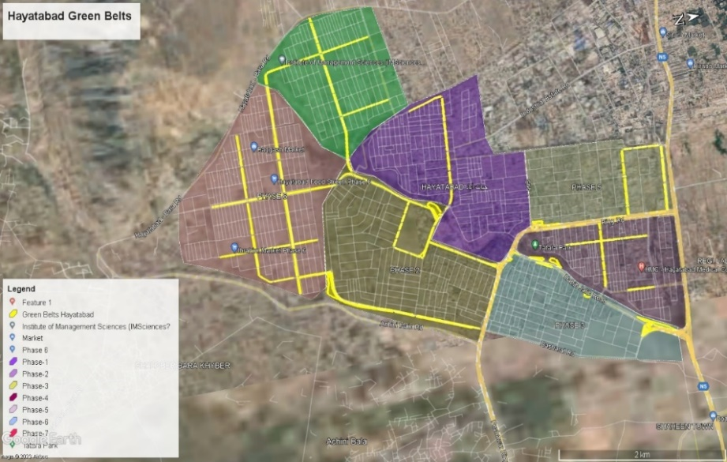

Figure1. Location map of Hayatabad, Peshawar

**Data Collection and Methods:**

To evaluate the irrigation requirements of Hayatabad’s green belts, a combination of techniques was employed, including satellite imagery analysis, field surveys, and data retrieval from the Peshawar Development Authority. Water requirements per unit area were computed and subsequently scaled up to determine the total water demand. The number of tankers needed was estimated by dividing the total water requirement by the capacity of a single tanker. Daily water consumption was calculated by multiplying the per-unit area requirement by the total green belt area. Data on tubewell depths were collected to compute the energy required for pumping operations. The number of mosques in Hayatabad and their associated population coverage were assessed. Specific water usage data from selected mosques were gathered, and water quality tests were conducted to determine per capita consumption rates. Storage tanks for repurposing ablution water for irrigation were designed, and assessments of potential energy conservation and economic feasibility were carried out. All estimates and analyses were refined using precise data, environmental considerations, and expert input to ensure reliable results.

**Site Selection:**

A representative mosque within Hayatabad was selected as the primary study site based on factors such as size, accessibility, daily footfall, the volume of water used for ablution, and proximity to green belts. This site was considered typical of urban mosques in the area and suitable for pilot-scale assessment.

**Data Collection:**

A digital water flow meter was installed at the mosque’s primary ablution point to accurately measure the volume of water used for ablution. Water usage was monitored during all five daily prayer times over four weeks to capture variations in consumption patterns. Additionally, data on energy consumption related to water pumping operations was collected using power meters and electric bills. This included both ablution-related water uses and conventional tubewell-based irrigation energy demands.

**Water Quality Assessment:**

Ablution water samples were collected from the selected mosque following sampling guidelines for irrigation water quality assessment in Pakistan. Biochemical Oxygen Demand (BOD) and Chemical Oxygen Demand (COD) were analyzed following the APHA Standard Methods (Method 5210 for BOD and Method 5220 for COD) to ensure reliable and standardized measurements.The methodology of the research is shown in Figure 2

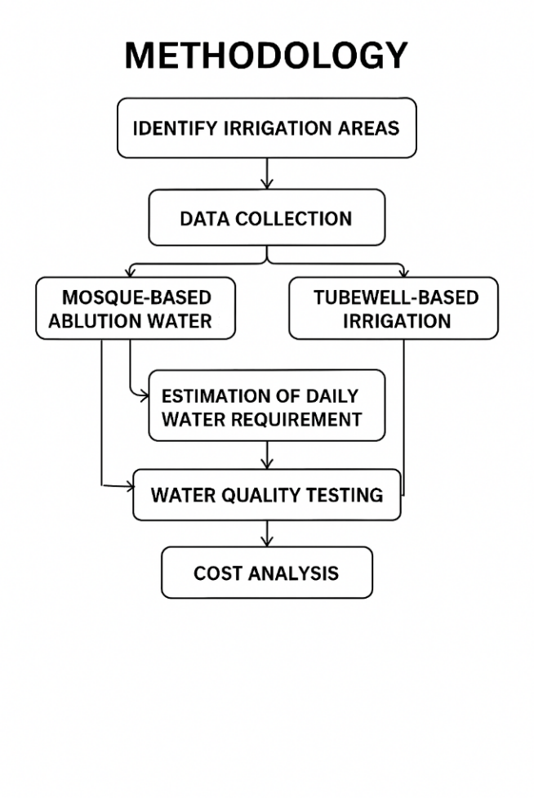

Figure2. Methodology of research

**Results and Discussion:**

**Ablution Water Per Namazi:**

For this analysis, six different mosques from various localities were selected. In each mosque, worshippers (Namazi) were observed during ablution, and the time taken for each individual to perform ablution was recorded using a stopwatch, as detailed in Table 1. For each recorded time, a graduated container was placed under the open tap to measure the volume of water used. This process was repeated for all other observed durations of tap usage to ensure accurate measurement of water consumption. Throughout the analysis, efforts were made to include participants from all age groups to capture the diversity in ablution habits and ensure that variations in water usage across different age demographics were accurately represented.

To ensure accurate estimation, all taps within each mosque were used during the data collection process, as each tap may vary in discharge rate. This approach accounted for differences in water flow among the taps. Volumes of all various recorded times from different taps giving all various volumes per namazi per ablution, thus an average is calculated.Average Water consumption from ablution water was calculated to be about 1200 liters per masjid.

**Pumping station (Masjids) and green belts of Hayatabad:**

The spatial analysis of Hayatabad, Peshawar, revealed that a total of 62 mosques are located within a 450-meter buffer of the main green belts, as shown in Figure 3. The yellow-highlighted areas indicate approximately 40.16 acres or 1749283.3ft2 of landscaped green belts distributed across Phases 1 to 7. This proximity enables the potential reuse of mosque ablution water as an irrigation source, reducing the average water transport distance from the source to green belts from 4 km (in the case of tubewells) to only 450 meters. This shorter distance significantly lowers pumping energy requirements and infrastructure costs. Additionally, the presence of 7 phases ensures that mosque-generated greywater can feasibly be matched with local irrigation demand across the township. This spatial alignment supports the design of decentralized irrigation systems powered by mosque ablution water reuse, enhancing both operational efficiency and sustainability

**Table 1**.Data collection from different masjid

|  |  |  |  |  |
| --- | --- | --- | --- | --- |
| **Mosque Name** | **Namaz Time** | **No of Namazis** | **No of Namazis Doing Ablution** | **Namazi's average water consumption per ablution in litres** |
| Masjid Ibrahim Phase 7, Hayatabad Peshawar | Fajr, Zuhr, Asr, Maghrib Isha | 45,60,40,55,60 | 20,38, 32, 39, 34 | 4.5 |
| Masjid Saad bin Abi Waqas Phase 6, Hayatabad, Peshawar | Fajr, Zuhr, Asr, Maghrib Isha | 35, 233, 245, 250, 555 | 18, 52, 67, 84, 91 | 5.1 |
| Masjid Jamiya Muhammadiyah, Phase 3, Hayatabad Peshawar | Fajr, Zuhr, Asr, Maghrib Isha | 25,140,155, 171, 188 | 15, 44, 62, 71, 79 | 4.8 |
| Masjid Bilal, Hayatabad Phase 1 Peshawar | Fajr, Zuhr, Asr, Maghrib Isha | 41,52,47,68,75 | 20,38, 32, 39, 34 | 4.7 |
| Masjid Mustafa Phase 3, Hayatabad, Peshawar | Fajr, Zuhr, Asr, Maghrib Isha | 35, 117, 140, 212, 301 | 18, 54, 57, 77, 98 | 5.5 |
| Masjid Jamiya Muhammadiyah, F-5 Phase 6, Hayatabad Peshawar | Fajr, Zuhr, Asr, Maghrib Isha | 25,113,120, 155, 197 | 17, 31, 48, 55, 60 | 4.9 |

**Table 2.** Green belt area in each phase

|  |  |  |
| --- | --- | --- |
| **S. No** | **Phase** | **Area (ft2)** |
| 1 | Phase-1 | 45202.8 |
| 2 | Phase-2 | 621164.9 |
| 3 | Phase-3 | 320914 |
| 4 | Phase-4 | 168113.4 |
| 5 | Phase-5 | 167549.9 |
| 6 | Phase-6 | 300439 |
| 7 | Phase-7 | 125900 |
| Total Area | | 174928.3 |

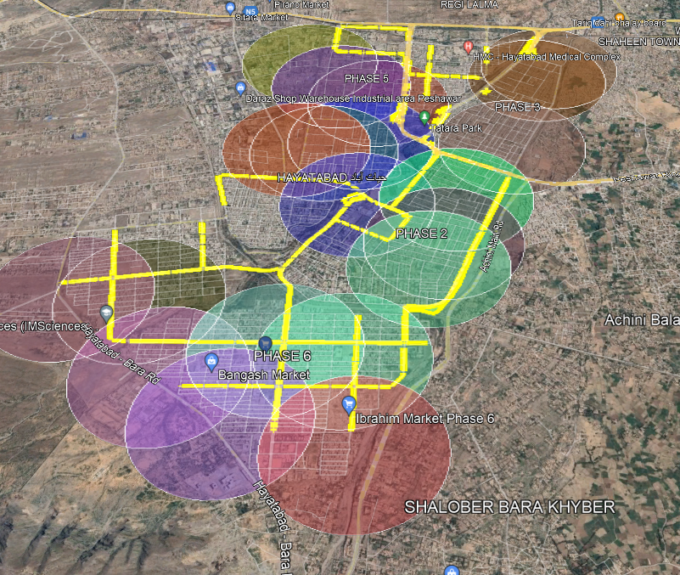

Figure3. Spatial distribution of mosques as potential pumping stations within a 450-meter buffer around green belts.

**Pumping station (Tubewell) and green belts of Hayatabad:**

Figure 4 highlights the spatial distribution of green belts (marked in yellow) and the locations of two primary tube well pumping stations (marked in blue) within the urban layout of Hayatabad, Peshawar. The spatial analysis, as shown in Figure 5, indicates that the two main tubewell pumping stations currently irrigate green belts distributed across Phases 1 to 7 within an average service radius of 4 km. This centralized system depends on groundwater extraction and requires higher pumping energy due to the longer distances between tubewells and the green belts they supply. In contrast, spatial data from Figure 3 shows that most green belts, 40.16 acres or 1749283.3ft2, are located within a 450-meter radius of mosques. This shorter distance significantly reduces the required pumping head and daily energy consumption.

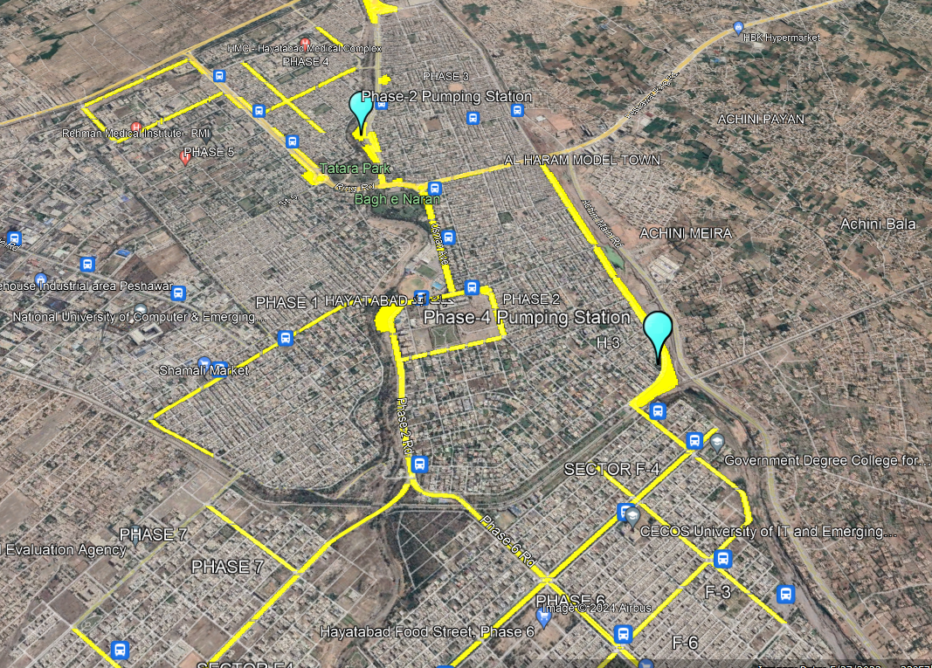

Figure4. Location of existing tubewells and their service areas relative to urban green belts.

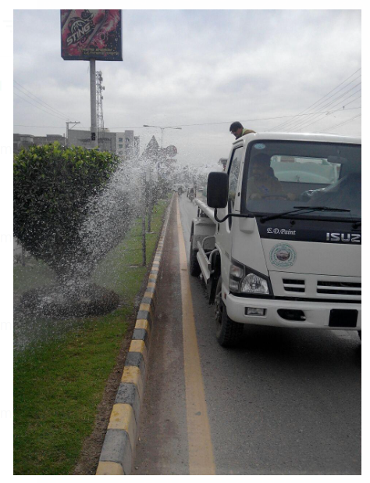

Figure5. Current irrigation practice in Hayatabad

**Difference in Average Water Consumption:**

The study came up with the result that an estimated 105,000 liters of water per day were consumed in the process of irrigating the green belts around 40 acres in Hayatabad. Seven specially designed tankers, all with a capacity of 5,000 liters, made 3 trips a day, supplying this volume. The mean of the number of liters of ablution water produced daily per mosque was approximately calculated at 1,000 liters in each mosque, with a standard deviation of 120 liters or less, signifying variation in the size of mosques and congregations. All the 62 mosques in the study area produced a volume of grey water per day of approximately 62,000 liters with a general margin of error of approximately 7 percent. These numbers illustrate the fact that though the supply of ablution water varied, the total amount that was made available showed a significant potential to meet or partially satisfy the daily irrigation requirement of lush green belts by the township.

**Comparison of irrigating the green belt from the Pumping station (tubewell) and Masjid’s Ablution water:**

The comparison revealed that ablution water reuse offers a more energy-efficient, low-cost, and sustainable solution for landscape irrigation, particularly in urban areas like Hayatabad, where mosques and green belts are closely located.

Maximum travel distance from the Tubewell to the farthest green belt was calculated to be 4km, and maximum travel distance from Masjid to the nearby farthest green belt was calculated to be 450 m, thus covering all green belts from all masjids of Hayatabad as shown in Figure 6.

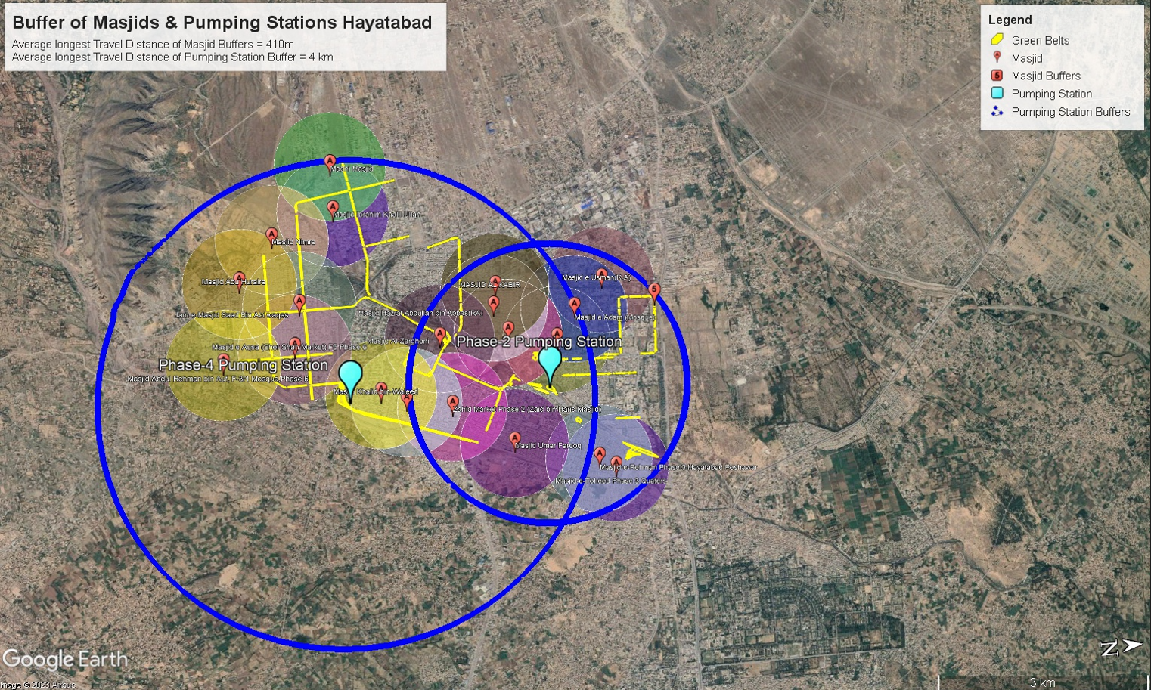

Figure6. Buffer of Masjid and the pumping station

**Cost Analysis:**

As Figure 6 indicates, the comparative daily operational cost of a conventional tubewell from a depth of 750ft based irrigation system and the proposed reuse green belt irrigation system of ablution water in Hayatabad was evaluated. The estimation was based on an electricity tariff of PKR 52 per kWh, and 60 HP (= 45 kW) and 0.5 HP (= 0.373 kW) pumps were assumed in the tubewell system and the mosque-based reuse system, respectively. The transport price of the tubewell water to the green belts was identified to be the steepest at PKR 8000 per day on account of long pipeline terrains, an average of 4 km. On the other hand, the ablution water transportation cost was relatively cheaper as compared to pumping higher water bill, as the green belts were within a range of 450 meters to the mosques, hence, shortening the pipeline length and the required pumps. The saving in time and energy was estimated to be as much as 13-fold in the cost of tubewell water as opposed to ablution water, whose cost was calculated to be much lower.

Likewise, the cost of running electricity to draw water out of tubewells was on average PKR 5,733 daily, which is attributed to a greater pumping head and greater pump capacity, whilst cost of running electricity to draw water out of ablution water was about PKR 3,692 daily, which is because less energy is used since the storage tanks are shallower and the pumps are smaller and the distance that the water must travel is also shorter.

**Water quality testing of Ablution Water:**

To evaluate the potential of ablution water reuse for landscape irrigation, Biochemical Oxygen Demand (BOD₅) and Chemical Oxygen Demand (COD) tests were conducted on both fresh groundwater (used in tubewell systems) and ablution greywater collected from a selected mosque in Hayatabad. The results showed that fresh water had BOD levels of 3–3.6 mg/L and COD values of 8–10 mg/L, which is expected for clean groundwater sources. In comparison, ablution water exhibited BOD levels of 4.6-6 mg/L and COD values ranging from 10-12 mg/L, as shown in Table 3.Both BOD and COD levels in the irrigation water samples were below the maximum allowable value of 10 mg/L and 90 mg/L.

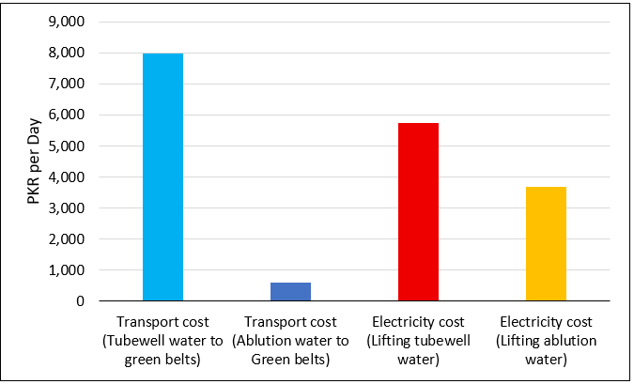

Figure 7. Comparative cost analysis of irrigation methods

Table3. Sample water quality result.

|  |  |  |  |  |  |  |
| --- | --- | --- | --- | --- | --- | --- |
| **Sample** | **BOD (mg/l)** | | | **COD (mg/l)** | | |
| Phase 7 | Phase 6 | Phase 4 | Phase 7 | Phase 6 | Phase 4 |
| Fresh Water Sample | 3 | 3.2 | 3.6 | 8 | 10 | 8 |
| Used Water Sample | 6 | 4.6 | 5.6 | 11 | 12 | 10 |

**Discussion:**

This study evaluated the feasibility of reusing mosque ablution water to irrigate green belts in Hayatabad, Peshawar, as a sustainable alternative to traditional tubewell-based irrigation [14], [15]. The spatial analysis demonstrated that approximately 62,000 liters of ablution water could be collected daily from 62 mosques, which are strategically located within an average 450-meter radius of the green belts. This proximity significantly reduced the need for long-distance pumping and transport, improving the overall energy and cost efficiency of irrigation operations. The cost and energy analysis revealed that the current tubewell system requires lifting water from a depth of 750 feet using 60 HP (≈45 kW) pumps, resulting in daily electricity costs of approximately PKR 5,733 and fuel costs of about PKR 8,000 for tanker transport. In contrast, the mosque-based system, using 0.5 HP (≈0.373 kW) pumps and shorter distribution distances, required only ~2 kWh of electricity daily (PKR 104) per tanker and about 2 liters of diesel (≈PKR 600) for tanker operations.

Greywater reuse has been successfully adopted in various parts of the world for landscape irrigation, toilet flushing, and industrial processes, offering considerable potential to reduce freshwater demand and improve resilience to water shortages [3], [16]. The integration of mosque-generated ablution water into the irrigation network offers a replicable and climate-adaptive model for cities facing water scarcity and growing urban demand [17].

**Conclusion:**

This study demonstrates that reusing ablution water from mosques for landscape irrigation in Hayatabad, Peshawar, offers a cost-effective, energy-efficient, and environmentally sustainable alternative to conventional tubewell-based irrigation systems. With minimal treatment, the ablution water meets acceptable BOD and COD levels for non-edible irrigation and is readily available within a 450-meter radius of most green belts, significantly reducing infrastructure and transport costs. The system not only cuts daily irrigation expenses by over 60% but also reduces the fuel consumption of tanker operations by more than tenfold, contributing to lower CO₂ emissions and helping mitigate global warming. Furthermore, the reuse of ablution water relieves pressure on underground aquifers, promotes energy savings through low-lift or gravity-fed systems, and aligns with national and global climate resilience goals. This approach supports Sustainable Development Goals (SDGs), particularly SDG 6 (Clean Water and Sanitation) and SDG 13 (Climate Action), and presents a scalable model for water-stressed urban areas. With strong community acceptance and clear environmental and economic benefits, this intervention offers a practical pathway toward sustainable urban water management in Pakistan and beyond.

**References**

[1] H. Rasheed, “Drinking water quality in Pakistan: Current status and challenges,” *Pakistan Counc. Res. water Resour. (PCRWR), Islam.*, vol. 141, 2021.

[2] N. Maqbool, “Pakistan’s Urban Water Challenges and Prospects,” *Pak. Dev. Rev.*, vol. 63, no. 3, pp. 417–430, 2024, doi: 10.30541/V63I3PP.449-462.

[3] K. B.-M. Ziad Al-Ghazawi, Ahmad Qasaimeh, “Ablution gray water qualitative assessment and treatment by submerged membrane bioreactor: a case study in Jordan,” *Desalin. Water Treat.*, vol. 127, pp. 213–221, 2018, doi: https://doi.org/10.5004/dwt.2018.22790.

[4] “Impact of Climate Change on Water in Pakistan,” *https://pide.org.pk/*.

[5] M. Rizwan *et al.*, “Simulating future flood risks under climate change in the source region of the Indus River,” *J. Flood Risk Manag.*, vol. 16, no. 1, p. e12857, Mar. 2023, doi: 10.1111/JFR3.12857.

[6] J. Raček, “Gray Water Reuse in Urban Areas,” *Springer Water*, pp. 195–217, 2020, doi: 10.1007/978-3-030-18359-2_8.

[7] N. S. & K. U. R. Shayan Ameer, Nisar Muhammad, Khan Zaib Jadoon, “A systematic literature review on potential of ablution greywater reuse: current insights, challenges, and future prospects,” *Appl. Water Sci.*, vol. 15, no. 173, 2025, doi: https://doi.org/10.1007/s13201-025-02488-0.

[8] R. DeFries and K. N. Eshleman, “Land‐use change and hydrologic processes: a major focus for the future,” *Hydrol. Process.*, vol. 18, no. 11, pp. 2183–2186, Aug. 2004, doi: 10.1002/HYP.5584.

[9] M. U. S. Saimar Pervez, Laiba Ahmed, Adeel Asif, Khawaja Zawar Ahmed, Kamran Manzoor, Babar Abbas, “Development and Application of Low-Cost Filtration System for the Treatment of Greywater of a Mosque,” *Tech. J. , UET Taxila*, vol. 3, 2024, [Online]. Available: https://tj.uettaxila.edu.pk/index.php/technical-journal/article/view/2066

[10] S. L. Shen, H. M. Lyu, A. Zhou, L. H. Lu, G. Li, and B. B. Hu, “Automatic control of groundwater balance to combat dewatering during construction of a metro system,” *Autom. Constr.*, vol. 123, Mar. 2021, doi: 10.1016/J.AUTCON.2020.103536.

[11] R. M. S. Radin Mohamed, A. Al-Gheethi, J. A. Rahman, A. H. Mohd Kassim, and S. Musa, “Reuse of Ablution Water to Improve Peat Soil Characteristics for Ornamental Landscape Plants Cultivation,” *MATEC Web Conf.*, vol. 103, Apr. 2017, doi: 10.1051/MATECCONF/201710305003.

[12] M. Abbas, P. G. Atangana Njock, and Y. Wang, “Influence of Climate Change and Land-Use Alteration on Water Resources in Multan, Pakistan,” *Appl. Sci. 2022, Vol. 12, Page 5210*, vol. 12, no. 10, p. 5210, May 2022, doi: 10.3390/APP12105210.

[13] Nazish Huma Khan, Mohammad Nafees, Tooba Saeed, Fazli Zuljajal, “Marble Production and Environmental Pressure: A Case Study of Hayatabad Industrial Estate Peshawar, Pakistan,” *Res. Sq.*, 2023, [Online]. Available: https://www.researchsquare.com/article/rs-3244303/v1

[14] Z. W. Kundzewicz, V. Krysanova, R. E. Benestad, Hov, M. Piniewski, and I. M. Otto, “Uncertainty in climate change impacts on water resources,” *Environ. Sci. Policy*, vol. 79, pp. 1–8, Jan. 2018, doi: 10.1016/J.ENVSCI.2017.10.008.

[15] H. M. Lyu, S. L. Shen, Y. X. Wu, and A. N. Zhou, “Calculation of groundwater head distribution with a close barrier during excavation dewatering in confined aquifer,” *Geosci. Front.*, vol. 12, no. 2, pp. 791–803, Mar. 2021, doi: 10.1016/J.GSF.2020.08.002.

[16] G. E. Moglen and G. E. Rios Vidal, “Climate Change and Storm Water Infrastructure in the Mid-Atlantic Region: Design Mismatch Coming?,” *J. Hydrol. Eng.*, vol. 19, no. 11, Nov. 2014, doi: 10.1061/(ASCE)HE.1943-5584.0000967.

[17] Roubi Zaied, “Water use and time analysis in ablution from taps,” *Appl. Water Sci.*, 2016, [Online]. Available: https://www.academia.edu/75178414/Water_use_and_time_analysis_in_ablution_from_taps

|  |  |
| --- | --- |
| Image result for CC BY | Copyright © by authors and 50Sea. This work is licensed under Creative Commons Attribution 4.0 International License. |