 | 
Geodemographic Assessment of Tuberculosis Patients Using Principal Component Analysis (PCA) in Gujranwala City, Pakistan
Muhammad Miandad, Tayyaba Khalid, Nida Shehzad, Siddiqua Bibi
University of Gujrat
*Correspondence: muhammad.miandad@uog.edu.pk
Citation| Miandad. M, Khalid. T, Shehzad. N, Bibi. S, “Geodemographic Assessment of Tuberculosis Patients Using Principal Component Analysis (PCA) in Gujranwala City, Pakistan”, IJIST, Special Issue pp 444-454, June 2024
DOI| https://doi.org/10.33411/IJIST/900
Received| June 10, 2024 Revised| June 15, 2024 Accepted| June 19, 2024 Published| June 28, 2024.
Introduction/Importance of the Study: Tuberculosis (TB) is a highly contagious disease caused by the bacterium Mycobacterium tuberculosis. It has persisted for centuries and primarily affects the lungs, spreading through airborne droplets. First identified by Robert Koch in 1882, TB remains a global health challenge. The World Health Organization (WHO) has been actively working to reduce TB incidence worldwide, and their efforts have led to a decline in infection rates over time. TB is closely related to geodemographic factors, which influence its prevalence and distribution.
Objective: This study aims to investigate the risk factors, spatial distribution, and hotspot areas of TB in Gujranwala city.
Material and Methods: Primary data were collected through questionnaire surveys, and secondary data were obtained from TB center records. These data were analyzed using statistical Principal Component Analysis (PCA) and Geographic Information System (GIS) software.
Novelty Statement: This study provides a geographical analysis of TB patients, offering significant insights that could enhance TB treatment strategies.
Results and Discussion: The analysis revealed that socioeconomic status, diet, diagnostic practices, and ecological conditions are key risk factors for TB. High-incidence areas are often characterized by poor ecological and economic conditions, predominantly inhabited by low- to middle-income labor class populations. Specific areas such as Ladhewala Wraich, Chicherwali, Kachi Phatuman, and Loyawala face ongoing environmental and socioeconomic challenges.
Concluding Remarks: Addressing these adverse conditions is crucial for reducing TB spread. Strengthening the immune system is also vital in preventing the disease. The government has a critical role in implementing measures to eradicate TB in Pakistan and improve overall public health.
Keywords: Tuberculosis, Socioeconomic, Principal Component Analysis, Gujranwala.
 |  |  |  | 
 |  |  |  | 
 |  |  |  | 

Introduction:
Tuberculosis (TB) is a contagious disease caused by the bacterium *Mycobacterium tuberculosis* and spreads through the air when an infected person coughs or sneezes [1]. It is a leading cause of death and ill health globally, predominantly affecting the lungs of adult males [2][29]. Despite its severity, TB is curable and controllable with a 6-month drug regimen and proper access to treatment through universal health coverage [3]. Since 1997, the World Health Organization (WHO) has been publishing annual data on TB cases to raise awareness and report progress at global, regional, and national levels as part of their commitment to TB strategies and targets [4]. Pakistan, the sixth most populous country in the world with over 200 million people [5], faces significant challenges in its healthcare system. Many citizens have limited access to quality medical services [6]. TB remains a major public health issue in Pakistan [7]. According to the WHO's 2014 report, Pakistan had the third highest number of TB cases in 2013, with a rate of 342 cases per 100,000 population. In 2014, there were 298,446 reported cases of TB [8].
In response to this high incidence, the Pakistani government established the National Tuberculosis Control Program to manage and reduce TB rates [9]. All TB cases are recorded and registered, with routine check-ups and diagnoses conducted to identify patients [10]. However, data on TB cases in the private sector are not consistently registered, complicating disease monitoring and patient treatment [11]. Additionally, according to [12], much data about diagnosed TB patients is lost, and some patients may not be diagnosed until symptoms are severe, resulting in incomplete registration [13]. The WHO reported a TB mortality rate of 23 per 100,000 population in Pakistan for 2015, the fifth highest globally [14]. In that year, 323,856 TB cases were reported, with an estimated 63% actual occurrence rate, and 32% of these cases were officially registered.
To tackle this issue, the WHO has implemented a comprehensive TB elimination strategy, urging all countries to act against TB [15]. This includes improving access to quality medical services and treatment, ensuring accurate diagnosis and registration of patients, and monitoring disease spread through regular data collection [15]. Despite these efforts, a significant number of TB cases in Pakistan remain unreported [16]. In 2015, approximately 180,000 TB patients were estimated to have gone unreported, representing nearly 5% of the global total [17]. The Pakistani government must enhance its TB control program to ensure proper diagnosis, registration, and treatment for all TB patients [18]. This involves increasing funding for the National Tuberculosis Control Program, providing training for healthcare workers, and improving the quality of medical services nationwide.
Material and Methods:
Study Area:
In recent years, Gujranwala has experienced significant growth in both population and infrastructure [19]. The city has been expanding continuously, with new commercial centers, housing developments, and public amenities emerging to accommodate its growing population [20]. Well-connected to other major cities in Pakistan, Gujranwala has become a prominent hub for trade and commerce [21]. Additionally, the city boasts a rich cultural heritage, evident in its numerous historical sites, monuments, and buildings scattered throughout [22].
One of the major challenges that Gujranwala is facing today is the issue of healthcare. Despite being one of the largest cities in Pakistan, Gujranwala still lacks adequate healthcare facilities, impacting the city's overall health. The city struggles with numerous health issues, including communicable diseases such as Tuberculosis (TB), which remains a major public health concern [23]. According to World Health Organization (WHO) reports, Pakistan has one of the highest rates of TB globally, and Gujranwala is no exception [24].
Research Design and Sample Size:
Data for this research was collected from two sources: primary data through face-to-face interviews using an open-ended and close-ended questionnaire, and secondary data from the DHQ Civil Hospital of Gujranwala. The questionnaire included 26 questions and 74 variables, covering aspects such as basic information, ecology, socioeconomic and demographic factors, diet, diagnosis, and awareness of TB. Primary data was gathered from DHQ and private TB diagnostic centers, while secondary data was sourced from the DHQ Civil Hospital over a four-year period (2015-2018). A sample size of 400 was selected from a population of 259,556, with a 95% confidence level and a 5% confidence interval. Data collection spanned one month, with data entered into Microsoft Excel and analyzed using SPSS version 20.
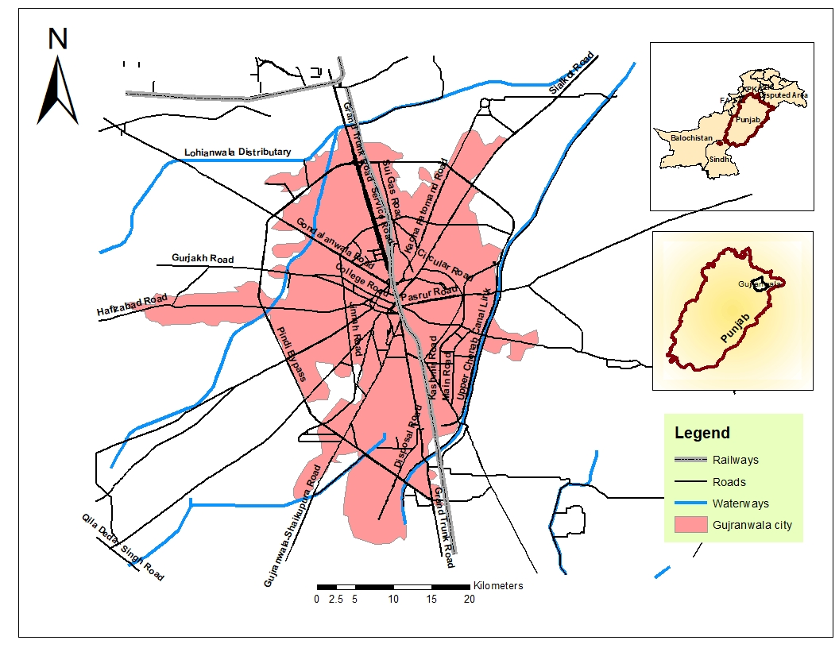
Figure 1: Study Area-Gujranwala city
Characteristics of Variables:
The research aimed to explore the relationship between tuberculosis and various socioeconomic and environmental factors, including poverty, education, housing conditions, diet, and awareness. Data was collected from 400 patients through face-to-face interviews. Analysis with SPSS version 20 indicated that poverty, illiteracy, and poor living conditions significantly contribute to the spread of tuberculosis. Individuals in low-income areas with inadequate housing, limited education, and low disease awareness are more susceptible to TB [25]. Additionally, smoking emerged as a significant risk factor in developing countries. The study underscores the importance of addressing these socio-economic and environmental factors for effective TB prevention and control.
Data Collection and Analysis:
Data was gathered from DHQ and TB clinic centers in Gujranwala to assess the impact of various factors on tuberculosis in the city. Collected data included information on patients, socioeconomic factors, ecological factors, diet, and diagnosis. Principal Component Analysis (PCA) and GIS software tools were employed for data analysis [26]. GIS played a crucial role in identifying hotspot areas and spatial distribution of TB patients. The questionnaire included open-ended questions to thoroughly explore patients' experiences and opinions. Remote sensing was utilized to analyze urbanization trends in Gujranwala, and GIS mapped hospitals, health facilities, and TB patient distribution for 2017, 2018, and post-primary data collection analysis [27].

Results and Discussion:
PCA was applied to the primary data collected through the questionnaire with 74 variables [28]. This analysis aimed to evaluate the quality of life of patients from a cause-and-effect perspective. The PCA results identified three key factors: Factor I represented the socioeconomic and demographic status, Factor II depicted socioeconomic and ecological status, and Factor III related to diet and diagnosis status. The variance of these factors provided insights into their significant impact on patients’ quality of life.
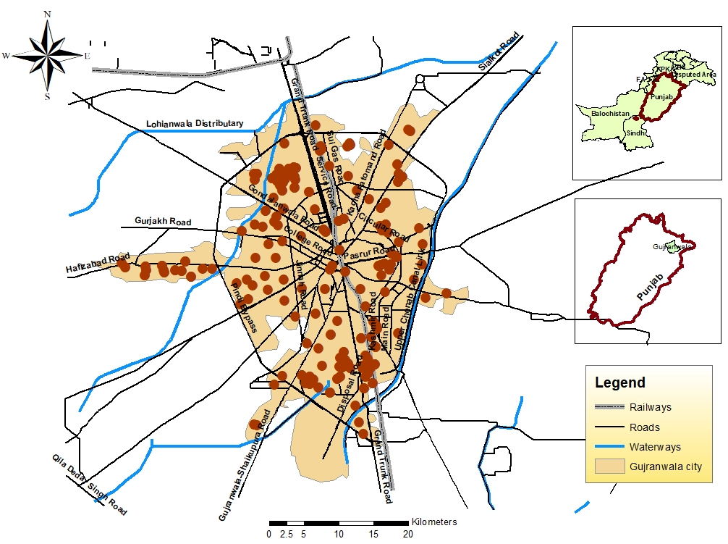
Figure 2: Spatial distribution of TB cases in Gujranwala city, 2017
Distribution of Tuberculosis in Gujranwala City:
Incidence of TB Cases in 2017:
In summary, the PCA analysis of diet and diagnosis factors in Gujranwala city revealed a strong correlation between tuberculosis diagnosis and the economic status and level of awareness/education of individuals. Residents from low- or middle-income brackets, particularly in hotspot areas such as Kangniwala, Loyawala, Lauhala Wraich, Shaheenabad, and Chicherwali, are more frequently diagnosed with TB. These areas are marked by low socioeconomic status, poor ecological conditions, and low literacy rates. The analysis also indicates that a balanced diet plays a crucial role in maintaining a strong immune system, which is essential for preventing tuberculosis.
Incidence of Tuberculosis Cases in 2018:
The spatial distribution of tuberculosis in Gujranwala city in 2018 closely mirrors that of 2017 (Figure 2). Areas with high TB incidence remain those with poor ecological and economic conditions, primarily inhabited by low- or middle-income individuals. These include areas such as Ladhewala Wraich, Chicherwali, Kachi Phatuman, and Loyawala. These regions continue to grapple with environmental and socioeconomic challenges. The lack of political focus on these areas has contributed to ongoing poor ecological conditions and a persistent rise in tuberculosis cases.
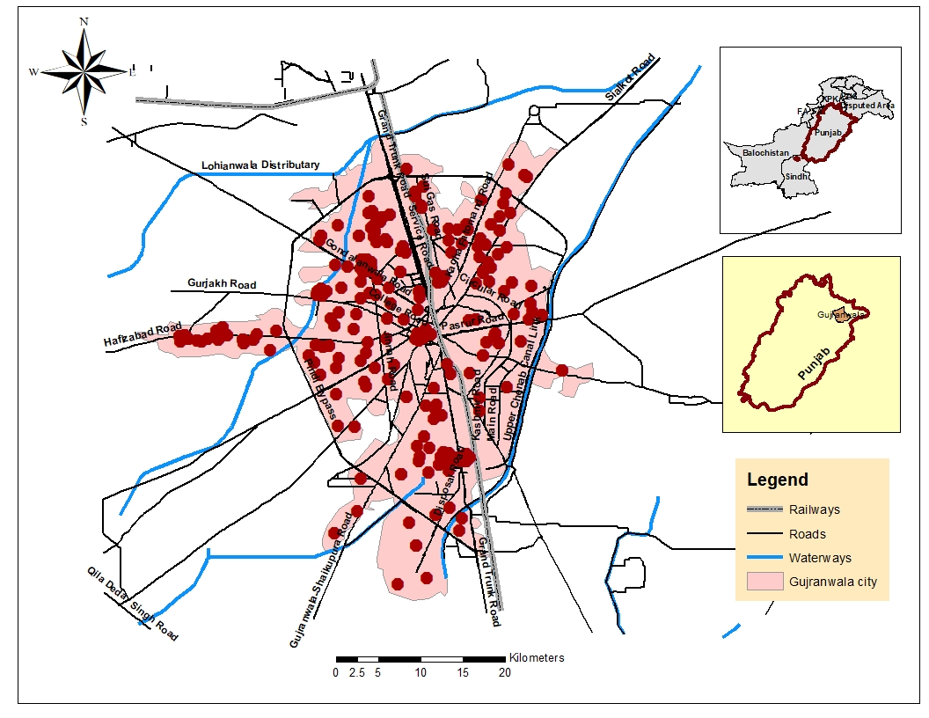
Figure 3: Spatial distribution of TB cases in 2018, Gujranwala city
Prevalence of Tuberculosis in Gujranwala City by Surveying:
In conclusion, the spatial distribution of tuberculosis in Gujranwala city identifies hotspot areas including Kachi Phatuman, Ladhewala Wraich, Chicherwali, Khiyali, the main city, Kangniwala, Dule, and Gharjkh (Figure 3). These regions are densely populated with low socioeconomic conditions, resulting in limited awareness and poor environmental conditions. Data collected from patient surveys indicate that low education, overcrowded housing, and poverty are key factors contributing to the spread of TB. The annual National Tuberculosis Program (NTP) report of Pakistan revealed that the situation remained stable from 2015 to 2016. TB affects both males and females equally, underscoring the need for targeted preventive strategies to enhance health and living conditions in these areas.
Factor I – Socioeconomic and Ecological Status:
In the PCA analysis, Factor I was used to illustrate the socioeconomic and ecological status of the patients (Figure 4). This factor accounts for 53.46% of the total variance. Significant positive values in Factor I ranged from .998 to .517, while the significant negative value was -.948. The highest positive values in Factor I were associated with 51 variables related to socioeconomic and ecological factors, including non-addicted patients, good ecological status, non-smokers, patients residing in middle-level housing, employed individuals, laborers, patients with 7-9 family members, those with an income of 15,000-25,000 PKR, families with more than 9 members, patients living in 1-3 room homes, those with education up to the matric level, unmarried individuals, those with personal businesses, divorcees, patients with incomes above 30,000 PKR, those living in houses with 4-6 rooms, male patients, and those with intermediate-level education.
However, the negative values in Factor I are associated with patients who smoke more than 10 cigarettes per day. This data indicates that tuberculosis patients often come from low- and middle-income families with limited education, primarily below the matric level, and are employed in labor-intensive industries. These patients also experience poor ecological conditions, such as congested living areas, numerous family members in small rooms, and proximity to garbage. Additionally, a lack of awareness about tuberculosis, reflected in the low literacy rate, exacerbates the situation. The PCA analysis of Factor I demonstrates a direct relationship between poor socioeconomic and ecological conditions and the prevalence of tuberculosis.
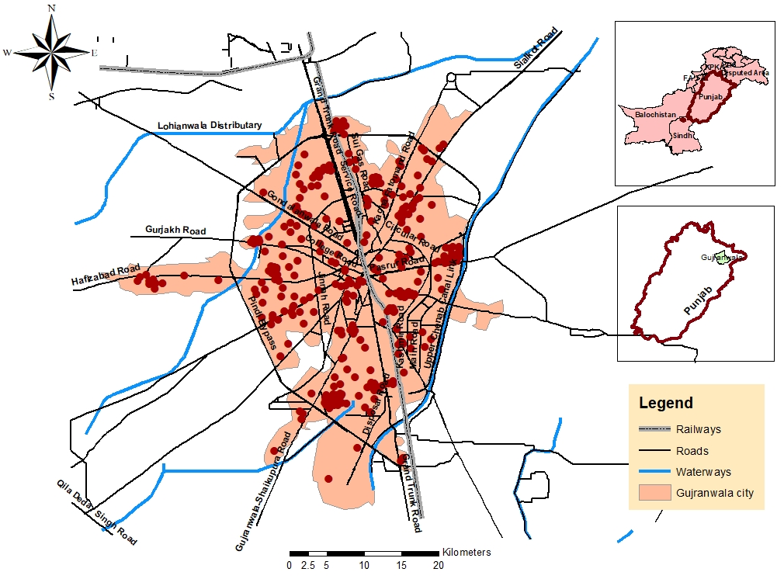
Figure 4: Spatial Distribution of tuberculosis by surveying, 2019
Factor II – Socioeconomic and Demographic:
Factor II elucidates the relationship between socioeconomic and demographic factors, including housewives (0.843), smokers living in joint families (0.834), patients in joint families (0.825), those living in 1-3 room homes (0.814), with 7-9 family members (0.796), unmarried individuals (0.792), non-addicted patients (0.787), those living in congested areas (0.766), patients with 4-6 room homes (0.740), and those in low-level residences (0.738). Conversely, Factor II shows negative significant values for patients with more than 9 family members (-0.871), those in high-level residences (-0.824), patients with 7-9 rooms (-0.794), those with 4-6 rooms living in joint families (-0.716), patients with separate rooms (-0.700), those in middle-level residences (-0.696), employed individuals (-0.689), patients with an income of 15,000-25,000 PKR (-0.667), those with personal businesses (-0.656), divorcees (-0.589), patients with intermediate education (-0.541), and male patients (-0.499).
Factor II highlights the link between smoking habits and the status of patients. Smokers, who live in poor conditions such as joint families, congested areas, and low-level residencies with fewer rooms, show a higher incidence of tuberculosis. The high illiteracy rate among patients is also a concern. Widows, housewives, and retirees are at a higher risk for the disease. The factor further illustrates a negative correlation between employment, having separate rooms, and intermediate education with tuberculosis. Factor II, which explains 26.13% of the variance, includes 16 positive and 13 negative significant values. It reflects that education is a key variable for improving quality of life, with low education or illiteracy linked to poverty and low-income jobs. Smoking, a significant social factor, directly impacts tuberculosis incidence. Gender and marital status also influence disease prevalence, with female patients having less external contact and widowed or divorced patients facing financial constraints affecting their diet. Overall, the socioeconomic status of patients, including income and family size, significantly impacts tuberculosis outcomes, with overcrowding and malnutrition being prevalent in underdeveloped countries like Pakistan and associated with the labor class and low income.
Table 1: Rotated Component Matrix
No. | Factor I |  |  | Factor II |  |  | Factor III
1  2  3  4  5  6  7  8  9  10  11  12  13  14  15  16  17  18  19  20  21  22  23  24  25  26  27  28  29  30  31  32  33  34  35  36  37  38  39  40  41  42  43  44  45  46  47  48  49  50  51  52  53  54  55  56  57  58  59  60  61  62  63  64  65  66  67  68  69  70  71  72  73  74 | FMDied_No  Non_Addicted  GNH_No  AR_TB_No  TBB_now_No  Congested  Age groups  Registered  No_separete_room  Middle  Months1_4TB  Once_a_week  Employed  Non_smoker  FTN_No  Any disease_No  Labour  Persons_7_9  Income_15000_25000  Twice_a_week  Persons_above 9  Rooms_1_3  FMDied_Yes  GNH_Yes  No_eat_meat  Join  FPCured_No  Matric  Vaccinated  Rooms_7_9  Primary  Un_married  FTN_Yes  Nucleated  FPCured_Yes  Personal_business  Months 5_8 TB  Divorce  Income_above 30000  Rooms_4_6  Female  Persons_4_6  Low  High  Intermediate  Income_25000_30000  Years 1_4TB  TBB_now_Yes  Male  Months 9_12 TB  Middle  Persons_1_3  Thrice_a_week  Unemployed  Once a _month  Non-vaccinated  Separate room  Sparse  Daily  Cigarette1_5  Graduation  Thrice a month  Unregistered  Cigarette 6_10  Illiterate  Retired  Addicted Twice  month  Smoker  Income_10000_15000  Any disease yes  Married  Widow  Above10_cigarette | .998  .993  .993  .993  .992  .991  .988  .988  .980  .975  .974  .969  .965  .959  .957  .948  .941  .941  .938  .911  .903  .885  .870  .868  .866  .859  .858  .850  .845  .842  .835  .818  .783  .778  .778  .773  .760  .749  .739  .738  .725  .709  .699  .696  .690  .678  .632  .629  .585  .522  .517  .449  .411  .375  .285  .258  .242  .218  .205  .124  .093  .088  .070  -.007  -.063  -.111  -.120  -.232  -.279  -.343  -.437  -.450  -.463  -.948 | Illiterate  Cigarette6_10  Cigarette1_5  Retired  Smoker  Addicted  Non_vaccineted  Widow  Anydisease_yes  Twice_month  Male  Married  Un_Registered  years1_4TB  Income_above 30000  FPCured_No  Persons_1_3  Sparse  Rooms_4_6  Join  Unemployed  Income 10000_15000  Rooms_7_9  FTN_No  Months 1_4 TB  Above 10_cigarette  No eat_meat  Persons_above 9  Persons_7_9  Separate_room  Income 25000_30000  Middle  Once a week  Employed  Months 9_12 TB  TBB_now_Yes  FMDied_No  GNH_No  No_separete_room  AR_TB_No  TBB_now_No  Non_Addicted  Registered  Age groups  Congested  Thrice_month  Twice_a_week  Labour  GNH_Yes  Income_15000_25000  Non_smoker  Low  Anydisease_No  Thrice_a_week  Personal_business  Once_a _month  Intermediate  Rooms_1_3  Primary  FMDied_Yes  High  Matric  Un_married  Vaccinated  Divorce  Persons_4_6  FTN_Yes  Months5_8TB  Graduation  FPCured_Yes  Daily  Nucleated  Female  Middle |  | .996  .991  .984  .965  .960  .956  .935  .874  .870  .795  .775  .772  .755  .706  .533  .501  .465  .465  .443  .435  .428  .312  .297  .244  .220  .195  .116  .114  .113  .106  .102  .096  .074  .052  .041  .033  .021  -.056  -.077  -.085  -.100  -.110  -.112  -.112  -.116  -.184  -.198  -.206  -.234  -.234  -.280  -.285  -.300  -.317  -.321  -.349  -.357  -.404  -.408  -.460  -.461  -.505  -.519  -.520  -.549  -.574  -.578  -.589  -.590  -.593  -.594  -.598  -.648  -.830 | Separate_room  Thrice_a_week  Graduation  Income_25000_30000  TBB_now_Yes  Intermediate  Twice_month  Personal_business  High-Residence level  Rooms_4_6  Persons_above9  Married  Twice_a_week  Sparse-area  Months5_8TB  Divorce  Join-family  Income above 30000  Addicted  Persons_7_9  Middle  Rooms_7_9  FPCured_Yes  Employed  Female  Cigarette 1_5  GNH_No  Registered  Age groups  AR_TB_No  Non_vacineted  Non_smoker  Non_Addicted  FMDied_No  Vaccinated  FTN_No  FTN_Yes  Congested  Anydisease_No  TBB_now_No  Anydisease_yes  Smoker  Illiterate  Once_a_week  Persons_1_3  Months 1_4 TB  FMDied_Yes  FPCured_No  Cigarette 6_10  Nucleated  Male  Income_15000_25000  Widow  Matric  Retired  Above 10_cigarette  Middle  No_separete_room  Un_married  Years 1_4 TB  Rooms_1_3  Labour  Primary  GNH_Yes  Persons_4_6  Unemployed  No_eat_meat  Un_Registered  Months 9_12 TB  Low  Income 10000_15000  Daily  Once_a _month  Thrice_month |  | .964  .824  .743  .704  .570  .566  .558  .536  .523  .497  .410  .389  .348  .314  .273  .273  .262  .258  .222  .211  .188  .185  .178  .161  .136  .120  .102  .089  .089  .085  .042  .041  .039  .039  .037  .037  .022  .014  .012  .010  .009  -.003  -.018  -.027  -.032  -.048  -.056  -.057  -.119  -.126  -.131  -.139  -.146  -.149  -.172  -.175  -.175  -.182  -.203  -.223  -.232  -.263  -.285  -.363  -.409  -.476  -.485  -.545  -.556  -.574  -.581  -.776  -.784  -.949
Factor III - Diet and Diagnosis:
The third factor, as shown in Table 1, accounts for 13.83% of the variance, with the highest positive and negative loading values in the rotated matrix being 0.964 and -0.949, respectively. Positive significant values range from 0.964 to 0.523, while negative significant values span from 0.545 to -0.949. This factor pertains to diet and diagnosis and includes 15 significant values. The highest positive loadings are associated with consuming meat three times a week (0.82) and having a previous history of tuberculosis (0.57). The highest negative loadings are observed for consuming meat once a month (-0.784) and three times a month (-0.949). This underscores the relationship between diet and tuberculosis diagnosis, emphasizing the role of a balanced diet in disease management. Malnutrition, prevalent in many underdeveloped regions, including Pakistan, is often linked to poverty and food insecurity, contributing to weakened immune systems and increased susceptibility to diseases like tuberculosis.
PCA analysis indicates that diet and diagnosis factors show lower values in some regions of Pakistan, where access to nutritious food is limited. While a balanced diet is crucial for maintaining a strong immune system, the economically disadvantaged in industrialized areas such as Gujranwala often cannot afford it. The correlation between good nutrition and socioeconomic status is significant for assessing patients' risk factors. Furthermore, diagnosis is closely linked to awareness and education, with many individuals delaying treatment due to a lack of awareness. This highlights the need for improved health education and quality healthcare services.

Conclusion:
Studies on the spatial epidemiology of tuberculosis in Gujranwala city have identified several key risk factors associated with the disease's spread. The most significant factors include low socio-economic status, poor education and literacy rates, high population density, and inadequate awareness about tuberculosis. Additional contributing factors are a high proportion of individuals in low-income jobs, overcrowded housing, and poor environmental conditions. Demographic data indicates that tuberculosis incidence is higher among males and that residents of Gujranwala often struggle to maintain a balanced diet. Smoking is also a notable risk factor, although patients are advised by doctors to quit this habit following diagnosis. These factors collectively contribute to the spread of tuberculosis in Gujranwala city, underscoring the urgent need for effective public health interventions to address the issue.
Acknowledgement: We are thankful to TB coordinator of Gujranwala Division for data.
Author’s Contribution: MM provide the concept of methodology and supervised the study, TK collection of data, field visits and write up, NS conducted statistical analysis, SB write up of literature and review the manuscript.
Conflict of Interest: Authors declare no conflict of interest for publishing this manuscript in IJIST.
References:
[1] C. Zemouri, S. F. Awad, C. M. C. Volgenant, W. Crielaard, A. M. G. A. Laheij, and J. J. de Soet, “Modeling of the Transmission of Coronaviruses, Measles Virus, Influenza Virus, Mycobacterium tuberculosis, and Legionella pneumophila in Dental Clinics,” J. Dent. Res., vol. 99, no. 10, pp. 1192–1198, Sep. 2020, doi: 10.1177/0022034520940288/ASSET/IMAGES/LARGE/10.1177_0022034520940288-FIG1.JPEG.
[2] H. J. Zar and T. W. Ferkol, “The global burden of respiratory disease—Impact on child health,” Pediatr. Pulmonol., vol. 49, no. 5, pp. 430–434, May 2014, doi: 10.1002/PPUL.23030.
[3] K. Floyd, P. Glaziou, A. Zumla, and M. Raviglione, “The global tuberculosis epidemic and progress in care, prevention, and research: an overview in year 3 of the End TB era,” Lancet Respir. Med., vol. 6, no. 4, pp. 299–314, Apr. 2018, doi: 10.1016/S2213-2600(18)30057-2.
[4] G. Sandhu, “Tuberculosis: Current situation, challenges and overview of its control programs in India,” J. Glob. Infect. Dis., vol. 3, no. 2, pp. 143–150, Apr. 2011, doi: 10.4103/0974-777X.81691.
[5] A. Rashid et al., “Ecological footprint of Rawalpindi; Pakistan’s first footprint analysis from urbanization perspective,” J. Clean. Prod., vol. 170, pp. 362–368, Jan. 2018, doi: 10.1016/J.JCLEPRO.2017.09.186.
[6] G. Thornicroft, D. Rose, and A. Kassam, “Discrimination in health care against people with mental illness,” Int. Rev. Psychiatry, vol. 19, no. 2, pp. 113–122, Apr. 2007, doi: 10.1080/09540260701278937.
[7] R. Fatima et al., “Building sustainable operational research capacity in Pakistan: starting with tuberculosis and expanding to other public health problems,” Glob. Health Action, vol. 12, no. 1, Jan. m, doi: 10.1080/16549716.2018.1555215.mia
[8] R. Fatima, “Title: Assessing the burden of missing tuberculosis cases in Pakistan”.
[9] D. C. Ogbuabor and O. E. Onwujekwe, “Governance of tuberculosis control programme in Nigeria,” Infect. Dis. Poverty, vol. 8, no. 1, pp. 1–11, Jun. 2019, doi: 10.1186/S40249-019-0556-2/TABLES/2.
[10] V. Smelov et al., “Rationale and Purpose: The FLUTE Study to Evaluate Fluorography Mass Screening for Tuberculosis and Other Diseases, as Conducted in Eastern Europe and Central Asia Countries,” Int. J. Environ. Res. Public Heal. 2022, Vol. 19, Page 8706, vol. 19, no. 14, p. 8706, Jul. 2022, doi: 10.3390/IJERPH19148706.
[11] A. Bennett, A. L. V. Avanceña, J. Wegbreit, C. Cotter, K. Roberts, and R. Gosling, “Engaging the private sector in malaria surveillance: a review of strategies and recommendations for elimination settings,” Malar. J. 2017 161, vol. 16, no. 1, pp. 1–19, Jun. 2017, doi: 10.1186/S12936-017-1901-1.
[12] A. Shekar P, H. Patel, A. Dumra, D. Reddy, K. S. Shivakumar, and P. Satish Kumar, “Presentation, management and outcomes of pediatric urogenital tuberculosis: 20 years’ experience from a tertiary center,” J. Pediatr. Urol., vol. 17, no. 4, pp. 546.e1-546.e8, Aug. 2021, doi: 10.1016/j.jpurol.2021.04.002.
[13] D. G. Storla, S. Yimer, and G. A. Bjune, “A systematic review of delay in the diagnosis and treatment of tuberculosis,” BMC Public Health, vol. 8, no. 1, pp. 1–9, Jan. 2008, doi: 10.1186/1471-2458-8-15/COMMENTS.
[14] M. R. Sarwar and A. Saqib, “Cancer prevalence, incidence and mortality rates in Pakistan in 2012,” Cogent Med., vol. 4, no. 1, p. 1288773, Jan. 2017, doi: 10.1080/2331205X.2017.1288773.
[15] K. Lönnroth et al., “Towards tuberculosis elimination: an action framework for low-incidence countries,” Eur. Respir. J., vol. 45, no. 4, pp. 928–952, Apr. 2015, doi: 10.1183/09031936.00214014.
[16] C. Mukhopadhyay, T. Shaw, G. M. Varghese, and D. A. B. Dance, “Melioidosis in South Asia (India, Nepal, Pakistan, Bhutan and Afghanistan),” Trop. Med. Infect. Dis. 2018, Vol. 3, Page 51, vol. 3, no. 2, p. 51, May 2018, doi: 10.3390/TROPICALMED3020051.
[17] W. S. Stevens, L. Scott, L. Noble, N. Gous, and K. Dheda, “Impact of the GeneXpert MTB/RIF Technology on Tuberculosis Control,” Tuberc. Tuber. Bacillus Second Ed., pp. 389–410, Sep. 2017, doi: 10.1128/9781555819569.CH18.
[18] J. Chakaya et al., “Global Tuberculosis Report 2020 – Reflections on the Global TB burden, treatment and prevention efforts,” Int. J. Infect. Dis., vol. 113, pp. S7–S12, Dec. 2021, doi: 10.1016/j.ijid.2021.02.107.
[19] I. A. Rana, S. S. Bhatti, and S. e Saqib, “The spatial and temporal dynamics of infrastructure development disparity – From assessment to analyses,” Cities, vol. 63, pp. 20–32, Mar. 2017, doi: 10.1016/J.CITIES.2016.12.020.
[20] M. Irfan, Y. Hao, M. Ikram, H. Wu, R. Akram, and A. Rauf, “Assessment of the public acceptance and utilization of renewable energy in Pakistan,” Sustain. Prod. Consum., vol. 27, pp. 312–324, Jul. 2021, doi: 10.1016/J.SPC.2020.10.031.
[21] M. W. Gondal, “URBANIZATION IN PAKISTAN AND CHALLENGES TO SOCIAL DEVELOPMENT,” Univ. PUNJAB, 2021.
[22] A. Siddiqa, “The New Frontiers: Militancy & Radicalism in Punjab,” 2013.
[23] A. Mahmood, A. Mahmood, R. N. Malik, and Z. K. Shinwari, “Indigenous knowledge of medicinal plants from Gujranwala district, Pakistan,” J. Ethnopharmacol., vol. 148, no. 2, pp. 714–723, Jul. 2013, doi: 10.1016/J.JEP.2013.05.035.
[24] S. S. Hasan, Z. U. Mustafa, C. S. Kow, and H. A. Merchant, “‘Sehat Sahulat Program’: A Leap into the Universal Health Coverage in Pakistan,” Int. J. Environ. Res. Public Heal. 2022, Vol. 19, Page 6998, vol. 19, no. 12, p. 6998, Jun. 2022, doi: 10.3390/IJERPH19126998.
[25] “Educational status and awareness among tuberculosis patients of Karachi - PubMed.” Accessed: Jun. 24, 2024. [Online]. Available: https://pubmed.ncbi.nlm.nih.gov/26968274/
[26] M. Miandad, F. Burke, S. Nawaz-Ul-Huda, and M. Azam, “Geodemographic analysis of tuberculosis patients in Karachi, Pakistan,” Hum. Geogr., vol. 9, no. 2, pp. 165–182, Nov. 2015, doi: 10.5719/HGEO.2015.92.4.
[27] M. Y. Mangi, Z. Yue, S. Kalwar, and Z. A. Lashari, “Comparative Analysis of Urban Development Trends of Beijing and Karachi Metropolitan Areas,” Sustain. 2020, Vol. 12, Page 451, vol. 12, no. 2, p. 451, Jan. 2020, doi: 10.3390/SU12020451.
[28] O. Wegelin et al., “Comparing Three Different Techniques for Magnetic Resonance Imaging-targeted Prostate Biopsies: A Systematic Review of In-bore versus Magnetic Resonance Imaging-transrectal Ultrasound fusion versus Cognitive Registration. Is There a Preferred Technique?,” Eur. Urol., vol. 71, no. 4, pp. 517–531, Apr. 2017, doi: 10.1016/J.EURURO.2016.07.041.
[29] Bagcchi, S. (2023). WHO's global tuberculosis report 2022. The Lancet Microbe, 4(1), e20. Mıandad, M., Anwar, M. M., Ahmed, S., Rahman, G., & Khan, M. A. (2019). Assessment of risk factors associated with spread of tuberculosis in Gujrat city Pakistan. Coğrafya Dergisi(39), 41-60.
 | Copyright © by authors and 50Sea. This work is licensed under Creative Commons Attribution 4.0 International License.

